**TECHNICAL ANALYSIS SCREENER_2 HEIKEN ASHI**

High Level Design & Low Level Design

**Document Control :**

|  |  |  |  |  |  |  |  |  |
| --- | --- | --- | --- | --- | --- | --- | --- | --- |
| **Technical Analysis Screener_2 Heikin Ashi** | | | | | | | | |
| Guided by-  **Mr. Sankar** |  |  | |  |  |  |  |  |
| **Date** | **Version** | **Author** | **Brief Description of Changes** | | | | **Approver Signature** | |
| December 07 2022 | 1.0 | Baradi Bindhu  Uppu Nimeesha  Remala Venkata Laxmi Nikhila  Bana Vijaya Laxmi  Rontala Ruchitha |  | | | |  | |

# 

**1. INTRODUCTION**

A stock screener is a set of tools that allow investors to quickly sort through the myriad of available stocks and increasing Exchange-traded funds according to the investor’s own criteria. Stock screeners are most typically available on brokerage trading platforms (usually free), but there are also some independent subscription-based stock screeners available. Stock screeners allow investors to employ their own methodology about what makes a stock or ETF valuable (longer-term traders) or spot a potential trading opportunity (shorter-term traders).

**1.1 BACKGROUND**

Technical analysis is an approach to predicting future price movements based on identifying patterns in prices, volume and other market statistics. Technical analysis usually proceeds by recording market activity in graphical form and then deducing the probable future trend from the pictured history. The premise is that prices exhibit various geometric regularities, which, once identified, inform the trader what is likely to happen next. This in turn allows the trader to run a profitable trading strategy. Technical analysis is prevalent in financial markets and is readily accessible in practitioner texts such as pring (2002), in the form of tools provided by online brokers such as Barclays Stockbrokers (www.stockbrokers.barclays.co.uk) as well as in the form of commentary in the financial and investment press.

**1.2 PURPOSE**

Technical stock screeners allow you to filter stocks according to many of the same price-dependent technical indicators that you would use on a stock chart. So, technical screeners can be extremely valuable for traders who normally trade momentum, reversal, or other short- and medium-term strategies.

**1.3 HOW STOCK SCREENERS WORK**

Stock screeners allow investors to weed through the extensive field of potential financial investments using their own criteria. Users begin the process by selecting certain investing parameters, based on their personal requirements.

For example, a fundamental investor may be most interested in market capitalization, analyst recommendations, earning per share (EPS), operating cash flow, multi-year return on investment (ROI), dividend yield, and the like. A technical trader would be more interested in moving average levels/crossovers, relative strength index (RSI) levels to indicate momentum, average directional index (ADX) readings to indicate strength, and chart patterns, among others.

**1.4 KEY PROJECT OBJECTIVES**

* To supply capital - To achieve this task, ownership in a private corporation is sold to the public in the form of shares of stock. Funds received from the sale of stock contribute to the firm’s capital formation.
* Toinspiresavings - This inspires people to save their income by making a profit. Continuous purchase and sale of securities on a stock exchange lead to the evaluation of their prices.
* Todevelop economy - It helps economic development by supplying the capital to the industries.
* To protect fraudulently**-**It is also to ensure that no fraudulence occurs in a transaction.
* To do long-term financing - Commercial banks generally disburse the short-term loan. So, supplying long-term finance is an objective of the stock exchange.

**1.5 FUNCTIONAL OVERVIEW**

**1.5.1 HEADER FILES**

* stdio.h
* stdlib.h
* string.h

**2.DESIGN OVERVIEW**

|  |  |
| --- | --- |
| **Name of the Module** | **File Operations** |
| Handled by | Uppu Nimeesha |
| Description | Declared and created files in the valid format and extension and researched about create and read operations |

|  |  |
| --- | --- |
| **Name of the Module** | **Add ,Update andDelete operations and error detection** |
| Handled by | Remala Venkata Laxmi Nikhila |
| Description | Developed code on update and add delete operations and implemented error detection and exceptional handling |

|  |  |
| --- | --- |
| **Name of the Module** | **Add,Update and Delete operations and research** |
| Handled by | Bana Vijayalakshmi |
| Description | Researched and developed all the conditions and functions on update and delete operations |

|  |  |
| --- | --- |
| **Name of the Module** | **Add,Update and Delete operations and research** |
| Handled by | Rontala Ruchitha |
| Description | Researched and developed all the conditions and functions on update and delete operations |

|  |  |
| --- | --- |
| **Name of the Module** | **Design testing and Data flow chart** |
| Handled by | Baradi Bindhu |
| Description | Developed code in creating sales record and designed dataflow diagrams and flow charts. |

**3. HEIKIN-ASHI**

## 3.1 What Is a Heikin-Ashi?

The Heikin-Ashi technique is used by technical traders to identify a given trend more easily. Hollow white (or green) candles with no lower Shadows are used to signal a strong Uptrend, while filled black (or red) candles with no upper shadow are used to identify a strong downtrend.

The Heikin-Ashi trading technique was developed by Munehisa Homma in the 1700s. The technique shares some characteristics with the traditional candlestick charts used in trading but differs in how the values for candlesticks are computed. In Japan, the word Heikin means “average” or “balance,” and the word Ashi means “bar” or “foot.” Hence, Heikin-Ashi means “average bar,” resonating with the trading technique, which uses the average price of the security.

### 3.2 Heikin-Ashi Formula

When calculating the Heikin-Ashi formula, we use the open-close data from the previous period and the open-high-low-close (OHLC) data from the current period. Modified OHLC values are displayed as candlesticks. The computations are as given below:

Heikin-Ashi Close = (Open() + High() + Low() + Close)/4

Heikin-Ashi Open = (HA Open(-1) + HA Close(-1))/4

Heikin-Ashi High = Max (High0, HA Open0, HA Close0)

Heikin-Ashi Low = Min(Low0, HA Open0, HA Close0)

Where:

* **HA** – Heikin-Ashi
* **-1** – Prior period figures
* **0** – Current period figure

Heikin-Ashi data can be of different time frames, i.e. intraday, weekly, or monthly, etc. The HA Open is always set to the midpoint of the body of the previous bar, and the HA Close is calculated as the average price of the current bar. The HA High is the highest value among the current high, HA Open, and HA Close. HA Low is the lowest value among the current low, HA Open and HA close.

**4. DETAILED SYSTEM DESIGN**

**4.1 DATA FLOW DIAGRAM**

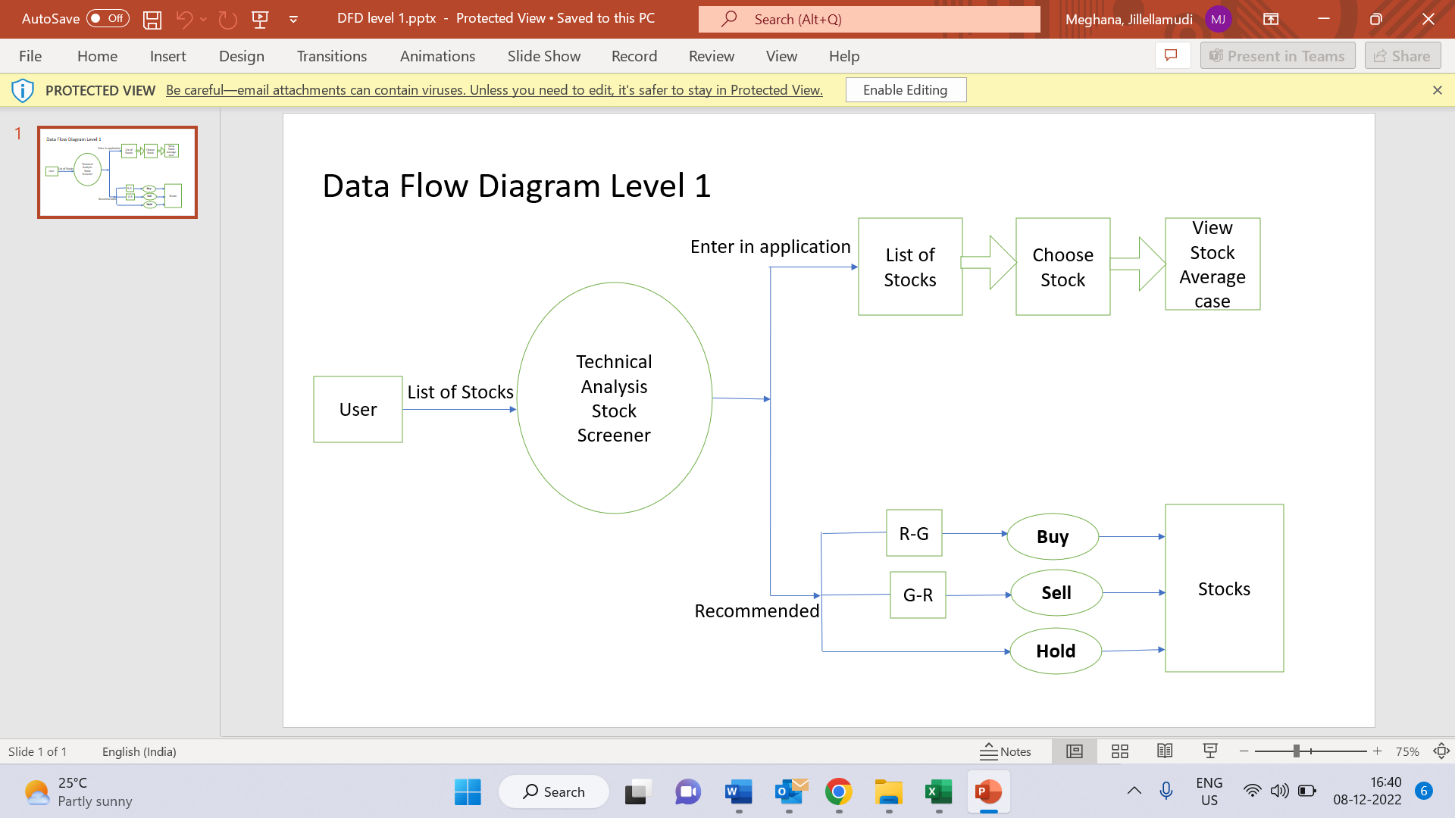

**4.2 DATA OVERVIEW**

**5. TOOLS REPORT**

**5.1 VALGRIND**

**5.2 SPLINT**

**6. TESTING**

**6.1 UNIT TESTING AND INTEGRATION TESTING**

**6.1.1 CREATE**

​4HH

**6.1.2 DISPLAY**

**6.1.3 APPEND**

**6.1.4 UPDATE**

**6.1.5 DELETE**

**6.1.6 HEIKIN ASHI**

**7.RTM**

